

**Continuing**

**Education**

**Program**

**Center for Computing and Information Technology**

**Faculty of EngineeringUniversity of Indonesia**

**PROJECT ON**

**“Rent House”**

**Group : 7**

**Muhammad Hudya Ramadhana**

**Mutia Ayu Dianita**

**­­**

**Faculty : Fachran Nazarullah S.Kom**

**Class : 4 SC 1**

Faculty of Engineering University of Indonesia

Depok 16424

2017

**PROJECT ON**

*Rent House*

Developed By

*Name : Muhammad Hudya Ramadhana*

*Mutia Ayu Dianita*

NIIT

**RENTHOUSE**

Batch Code : 4 SC 1

Start Date : March 24th, 2017

End Date : April 10th, 2017

Name Of The Coordinator : Fachran Nazarullah S.Kom

Name Of Developer : Muhammad Hudya Ramadhana

Mutia Ayu Dianita

Date Of Submission : April 11th, 2017

NIIT

**CERTIFICATE**

This is to certify that this report, titled Rent House embodies the original work done by ***Muhammad Hudya Ramadhana and Mutia Ayu Dianita*** in partial fulfillment of their course requirement at NIIT.

Coordinator:

*Fachran Nazarullah S.Kom*

**ACKNOWLEDGEMENT**

We have benefited a lot from the feedback and suggestions given to us by Mr. Fachran Nazarullah S.Kom and other faculty members. The Project presentation opportunity we have with CCIT-FTUI is a greatchance for learning and professional development. Therefore, we consider ourselves very lucky as we are provided with an opportunity to be a part of it. We are also grateful for having a change to meet so many wonderful people and professionals who led us through this project period.

Bearing in mind, we would like to express our deepest gratitude and special thanks to Mr. Fachran Nazarullah S.Kom of CCIT-FTUI faculty who is spite of being extraordinarily busy with her duties, took time out to hear, guide and keep us on the correct path and allowing us to carry out our project until completion.

Our Project assignment won’t be as good as it is now without any help, feedback and suggestion that were given to us by our friends within the campus. So, we would also like to say thank you to all of them. We will strive to use gained skills and knowledge in the best possible way, and we will continue to work on the improvements, in order to attain desired career objective.

**SYSTEM ANALYSIS**

**System Summary:**

The proposed software system for Rent House will be used by two different types of user:

1. Admin
2. Customer

The proposed software system needs to provide the following functionalities to the Admin of Rent House:

1. Allow Admin to Add and Modify Room Types Data.
2. Allow Admin to Add and Modify Room Data.
3. Allow Admin to Add and Modify Operator Data.
4. Allow Admin to Add and Modify Customer
5. Allow Admin to Add Transaction (Rent In or Rent Out)
6. Allow Admin to Add Monthly Paid of Customer

The proposed software system also provide the following functionality to the Customer of Rent House :

1. Allow Customer to View Available Rooms in Rent House

**HARDWARE AND SOFTWARE REQUIREMENTS**

**Hardware: Asus Expert 50, Intel(R) Core(TM) i38.00 GB (RAM)**

**Operating System: Microsoft Windows 8.1 Pro, 64-bit Operating System**

**Software: Astah Jude Professional**

**SQL Server 2015**

**Netbeans IDE 8.0.2**

**INDIVIDUAL PROJECT SCHEDULE**

|  |  |  |  |  |  |
| --- | --- | --- | --- | --- | --- |
| **S. No** | **Activity Description** | **Planned Date of Completion** | **Actual Date** | **Responsibility** | **Remarks** |
| 1 | Creating the UML Diagrams | 5th April 2017 | 5th April 2017 | Mutia |  |
| 2 | Creating the Home Page | 7th April 2017 | 7th April 2017 | Mutia |  |
| 3 | Creating Login Page | 7th April 2017 | 7th April 2017 | Hudya |  |
| 4 | Creating Customer Pages | 9th April 2017 | 9th April 2017 | Hudya |  |
| 5 | Creating Room Type Pages | 9th April 2017 | 9th April 2017 | Mutia |  |
| 6 | Creating Room Pages | 9th April 2017 | 9th April 2017 | Mutia |  |
| 7 | Creating Transaction Pages | 10th April 2017 | 10th April 2017 | Hudya |  |
| 8 | Creating Monthly Paid Pages | 10th April 2017 | 10th April 2017 | Hudya |  |

**ACTIVITY DIAGRAM FOR RENT HOUSE**

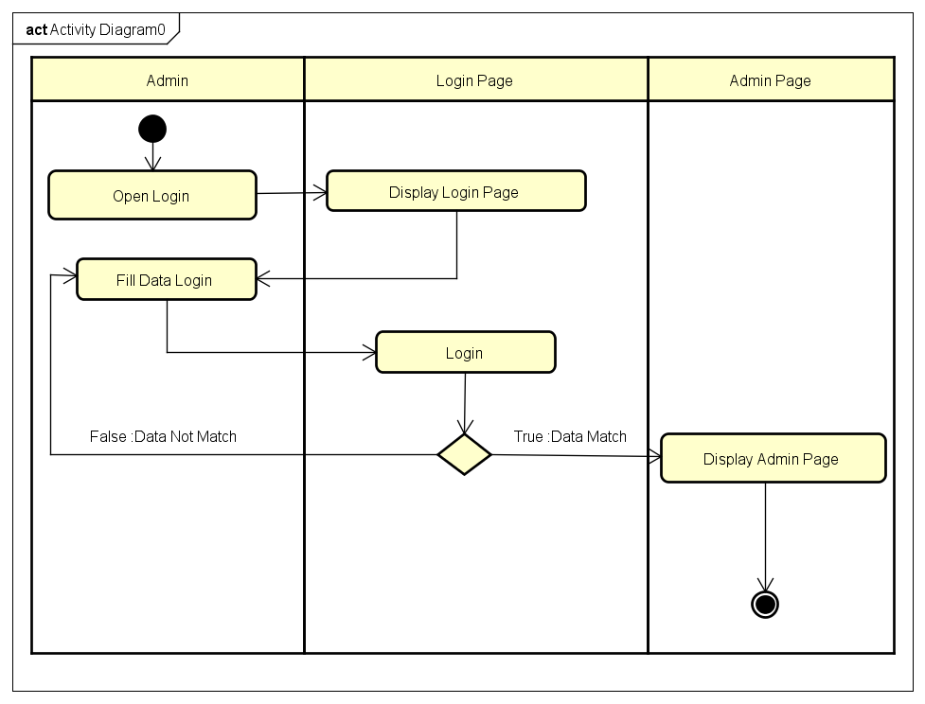

*Activity Diagram Login*

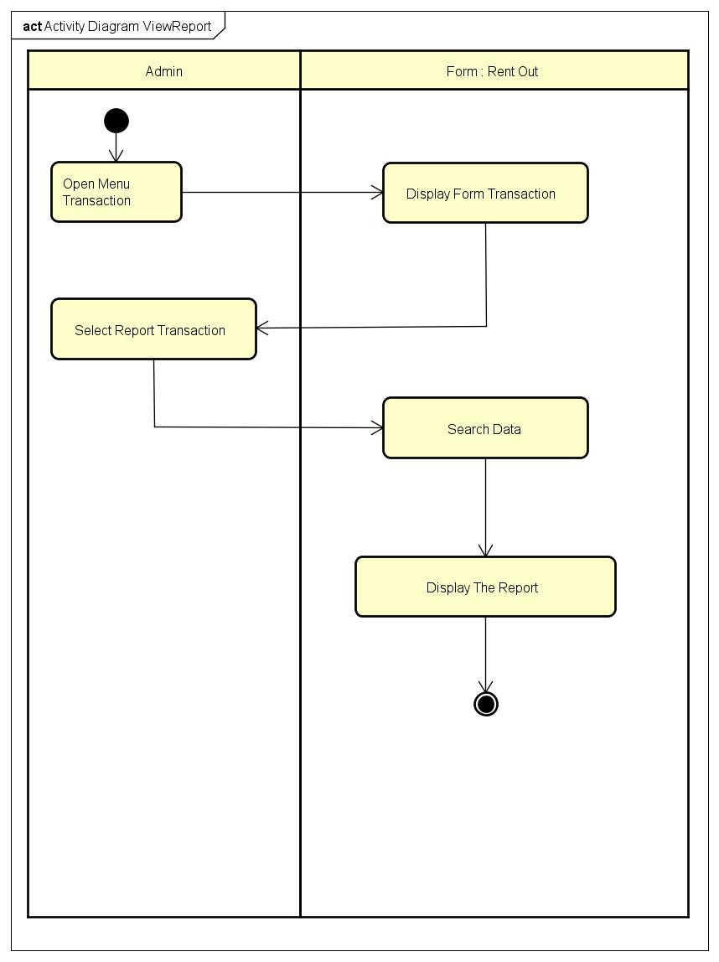

*Activity Diagram Display Report*

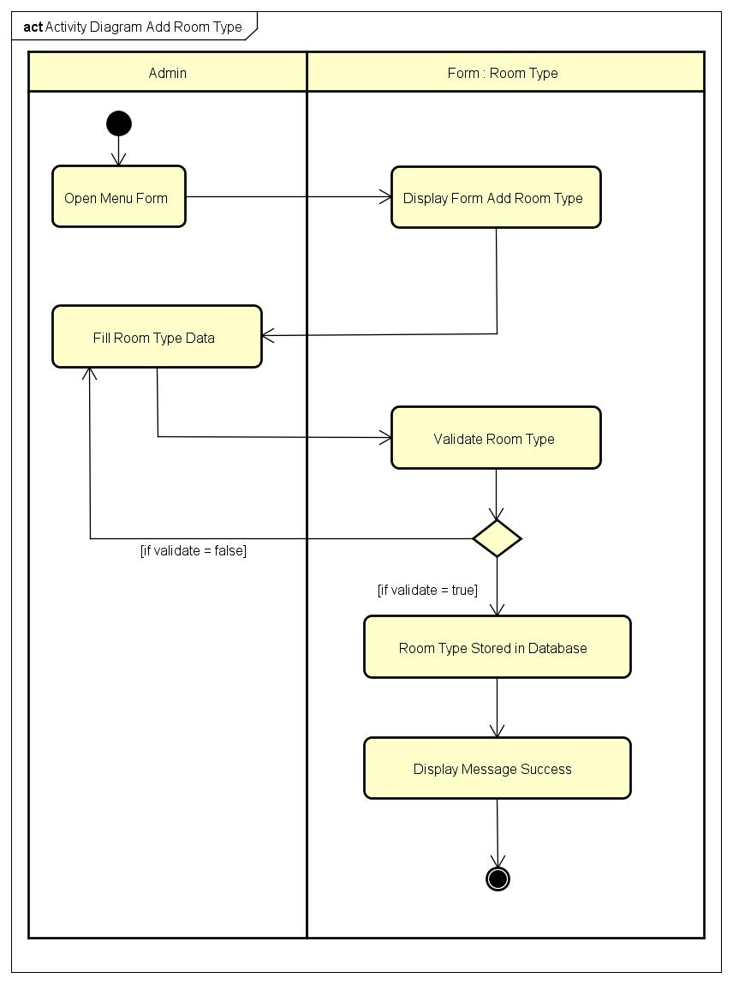

*Activity Diagram Add Room Type*

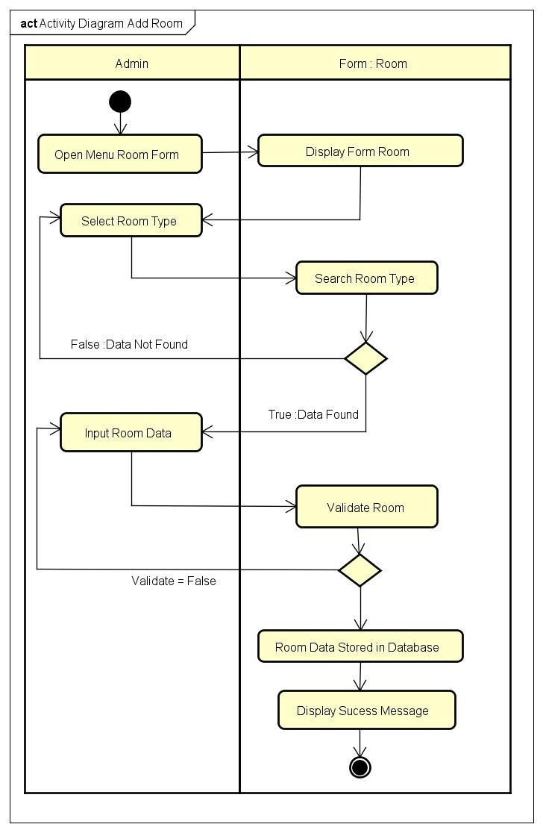

*Activity Diagram Add Room*

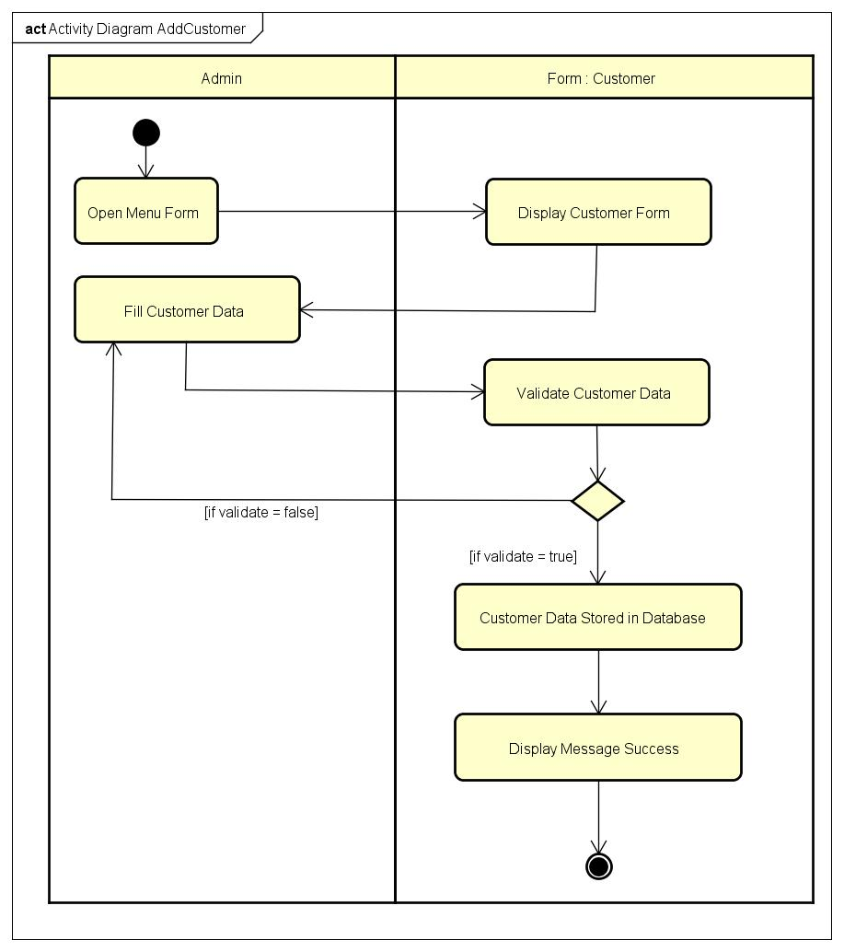

*Activity Diagram Add Customer*

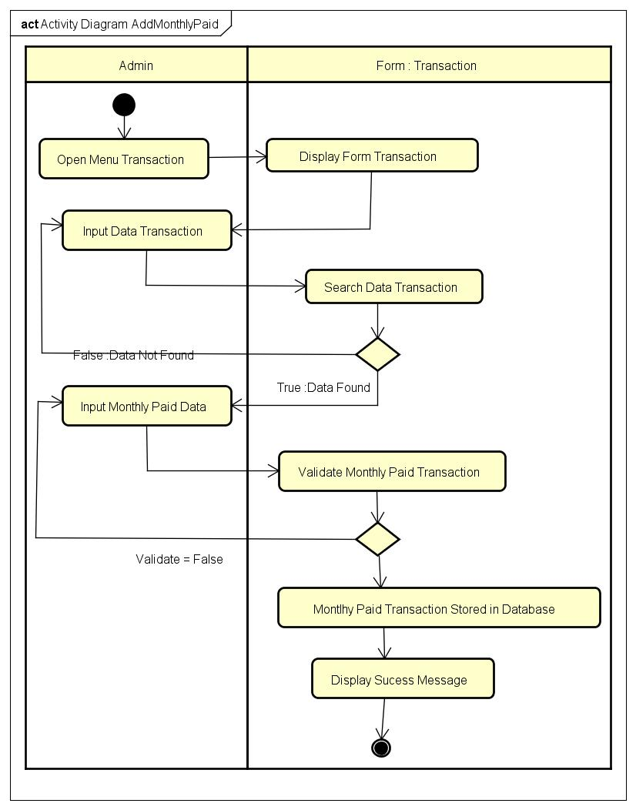

*Activity Diagram Add Monthly Paid*

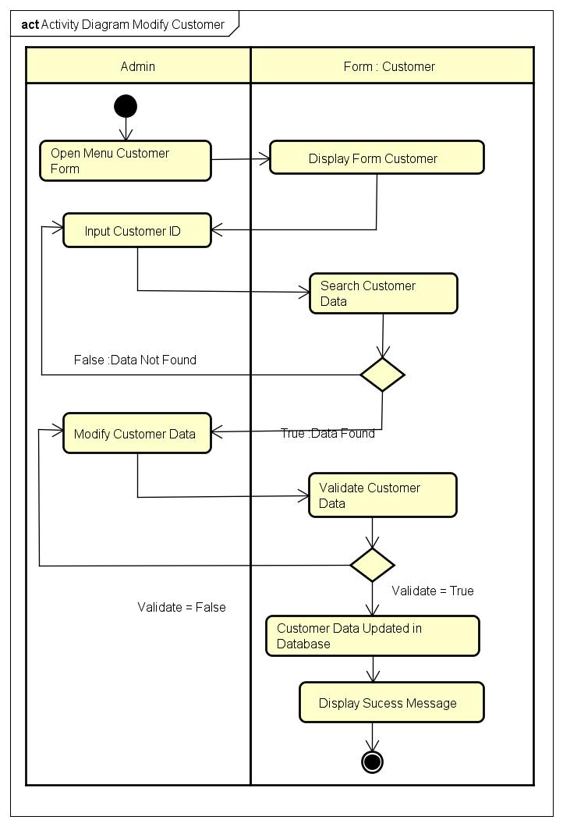

*Activity Diagram Modify Customer*

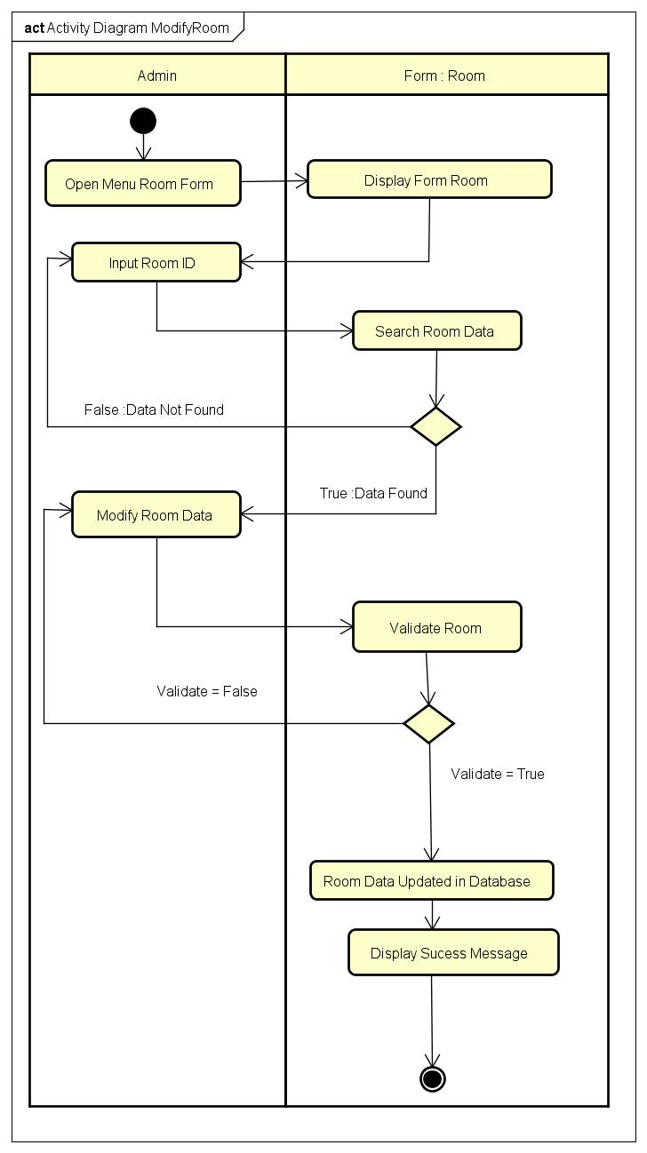

*Activity Diagram Modify Room*

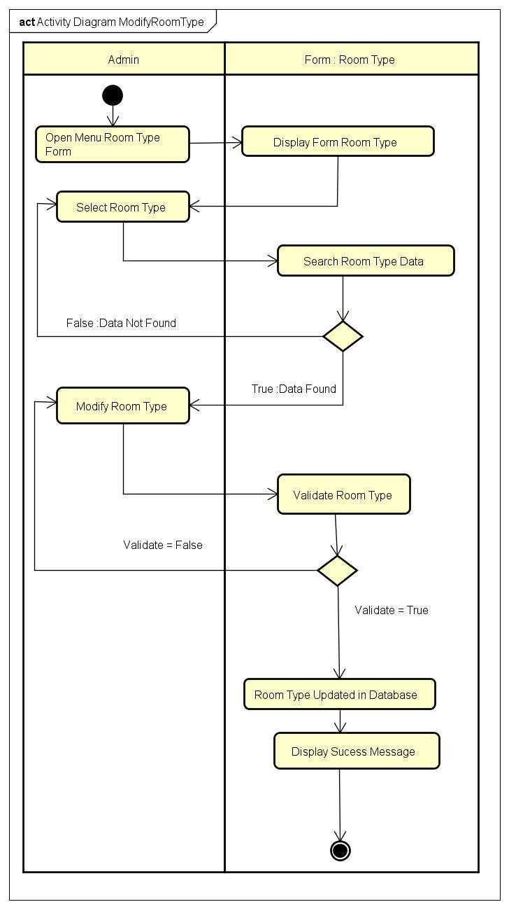

*Activity Diagram Modify Room Type*

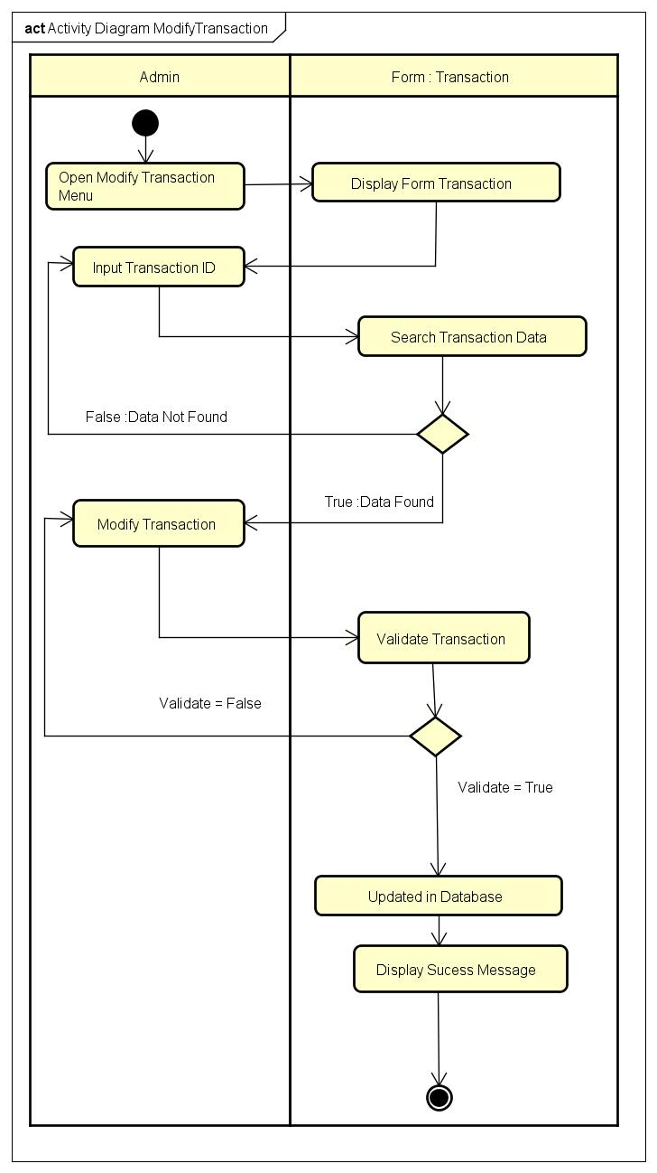

*Activity Diagram Modify Transaction*

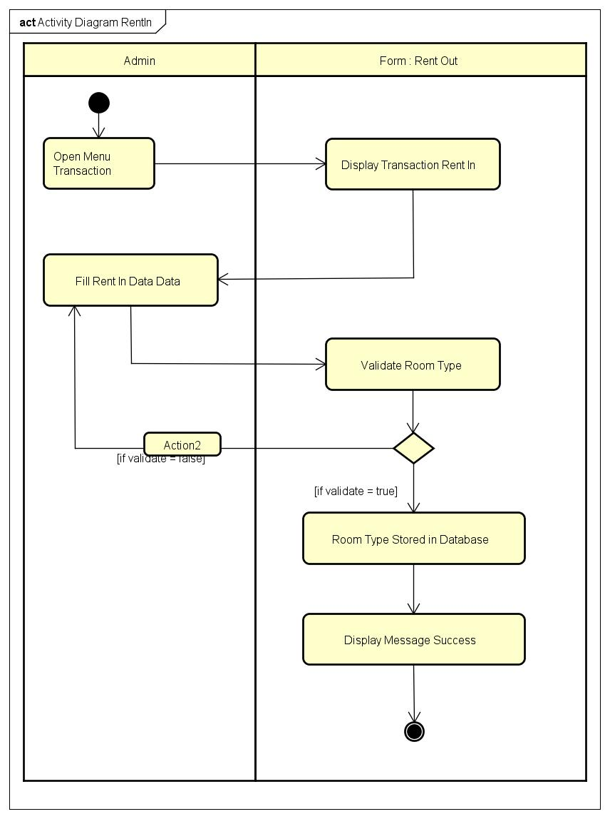

*Activity Diagram Rent In*

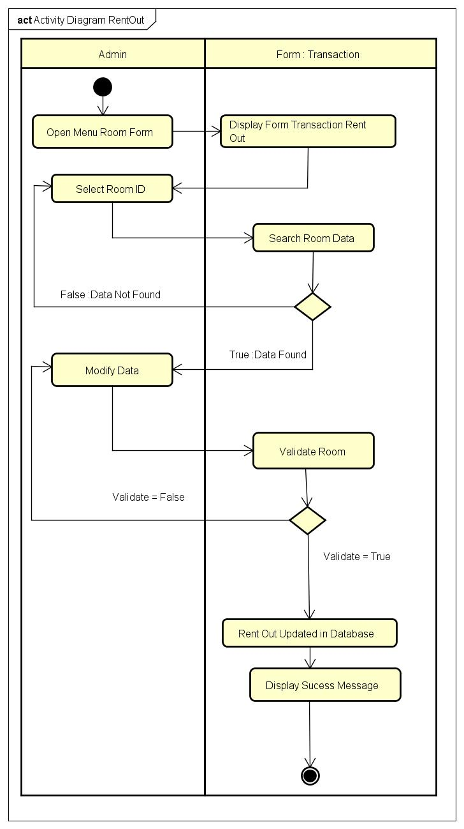

*Activity Diagram Rent Out*

**SEQUENCE DIAGRAM FOR RENT HOUSE**

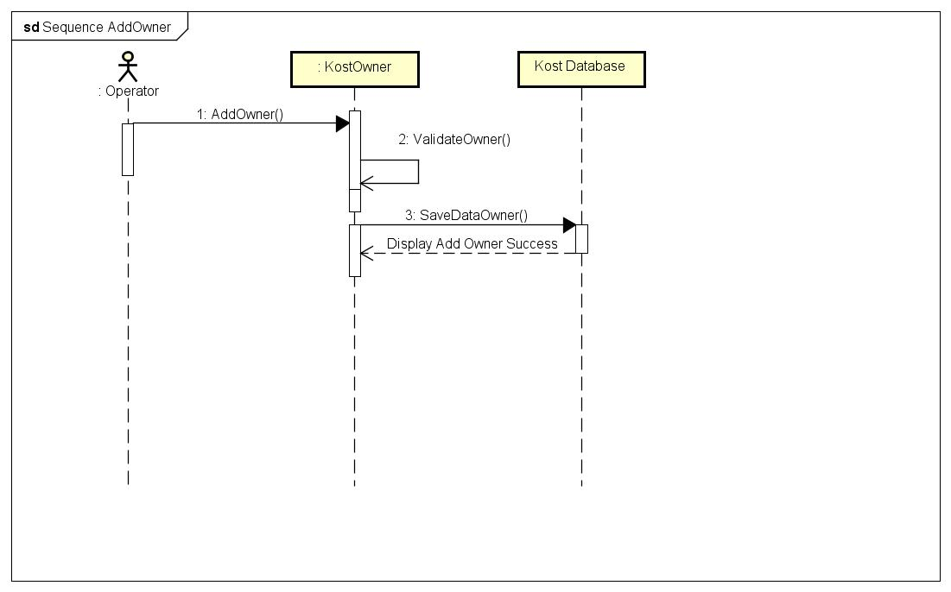

*Sequence Add Owner*

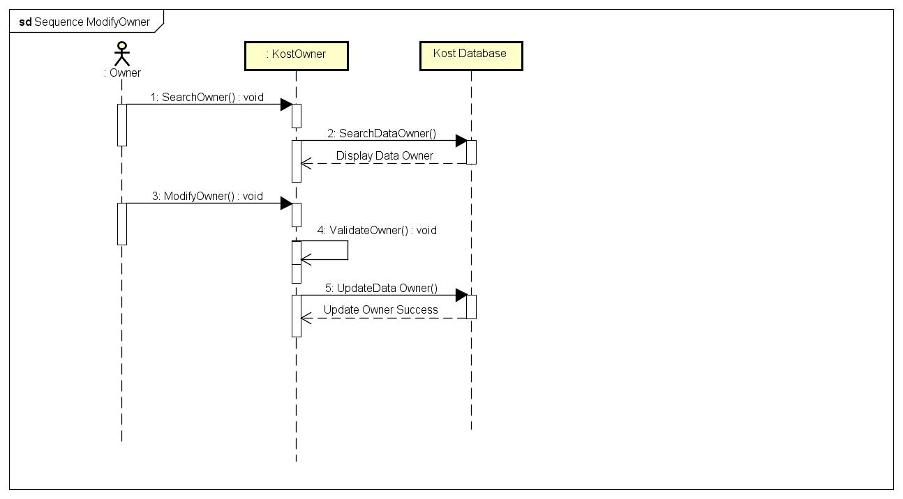

*Sequence Modify Owner*

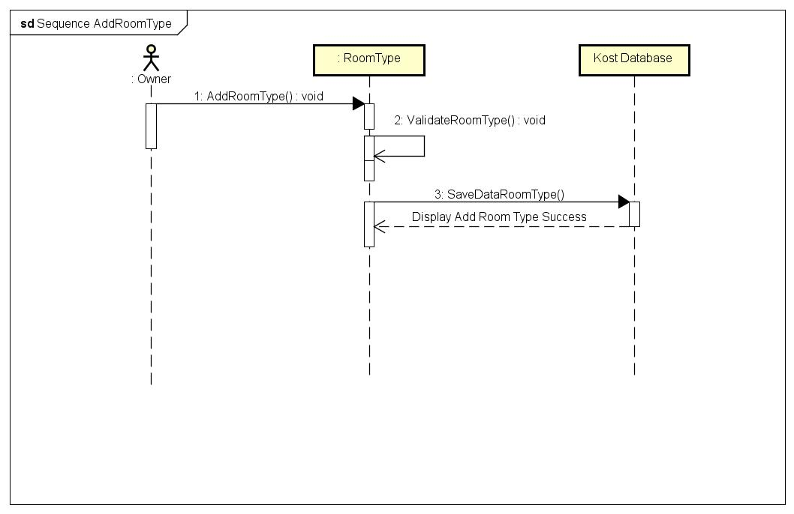

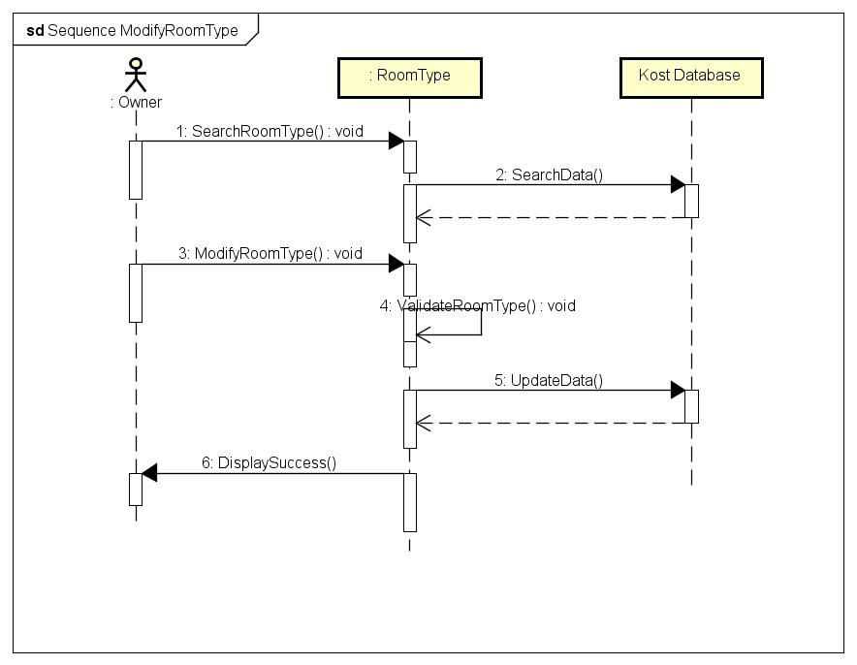

*Sequence Modify Room Type*

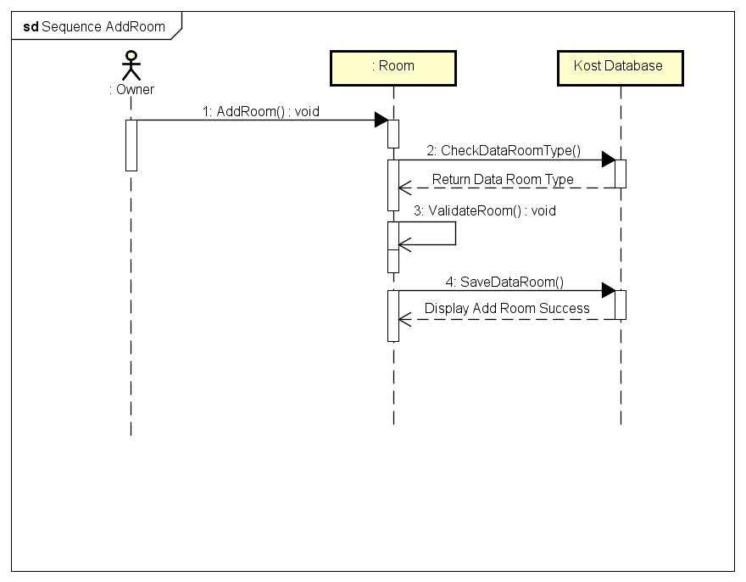

*Sequence Add Room*

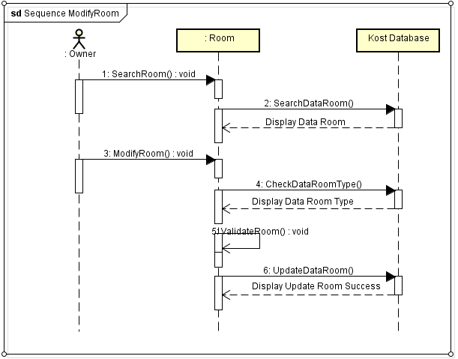

*Sequence Modify Room*

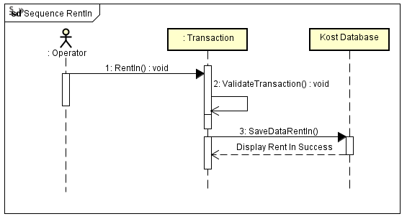

*Sequence Rent In*

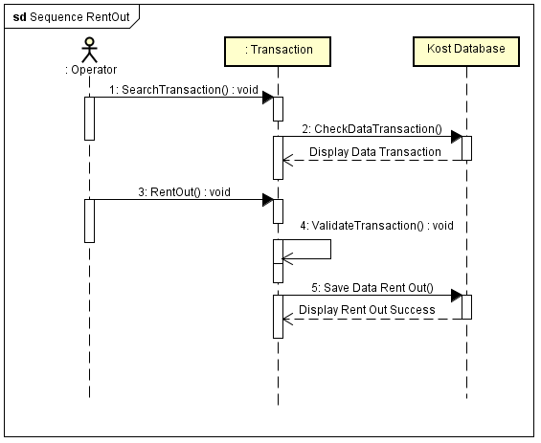

*Sequence Rent Out*

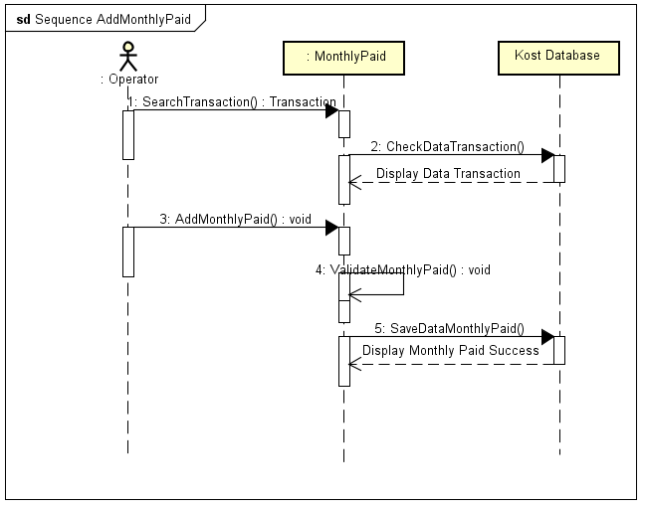

*Sequence Add Monthly Paid*

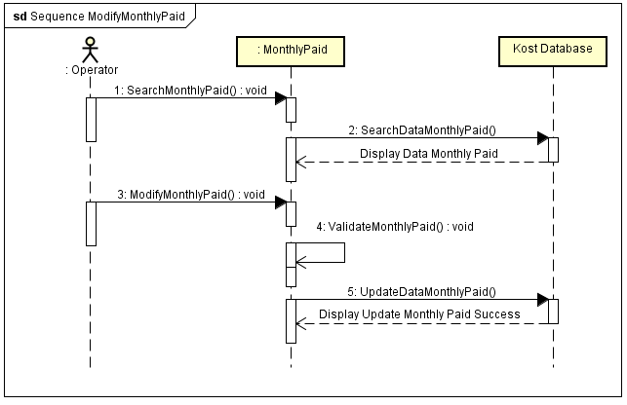

*Sequence Modify Monthly Paid*

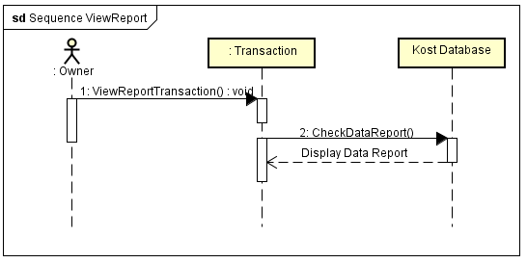

*Sequence View Report*

**USE CASE DIAGRAM FOR RENT HOUSE**

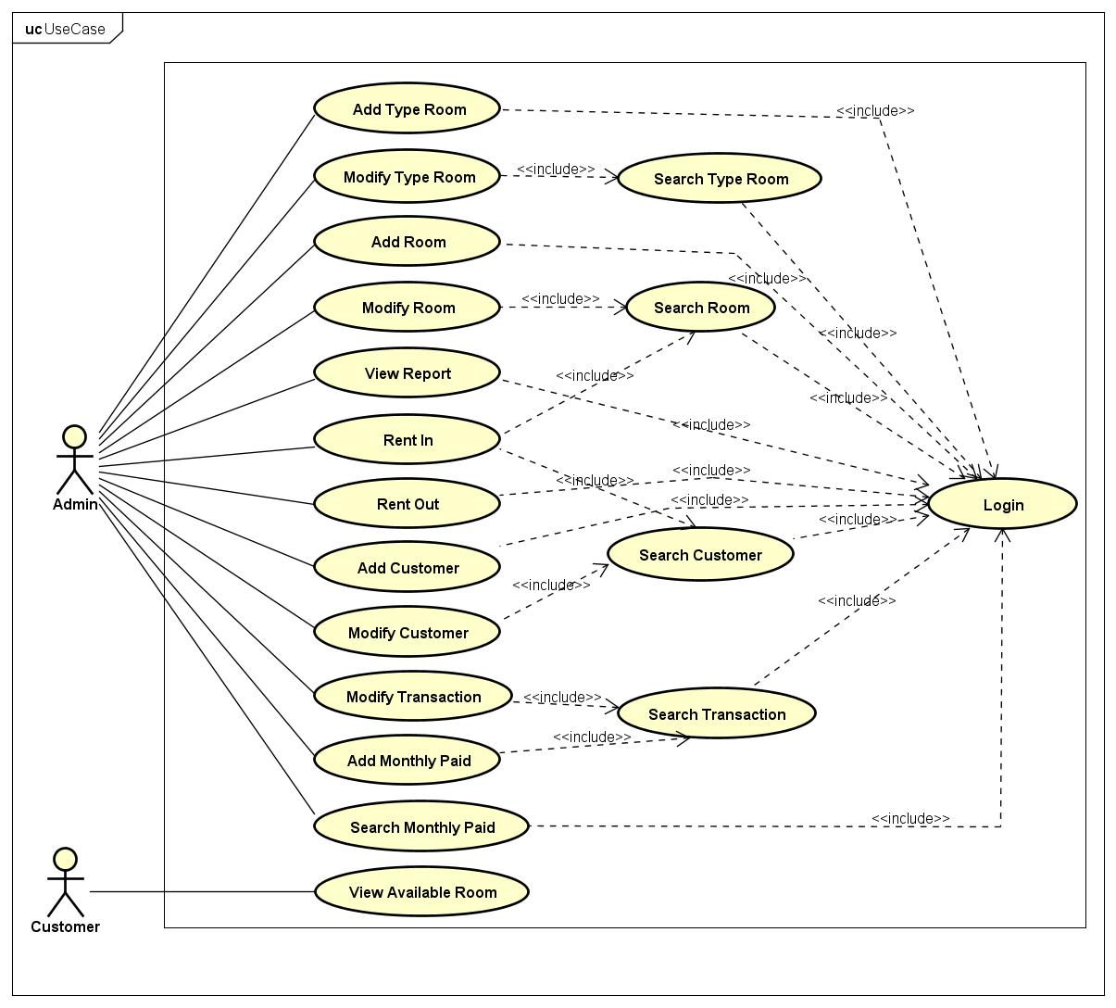

*Use Case Diagram*

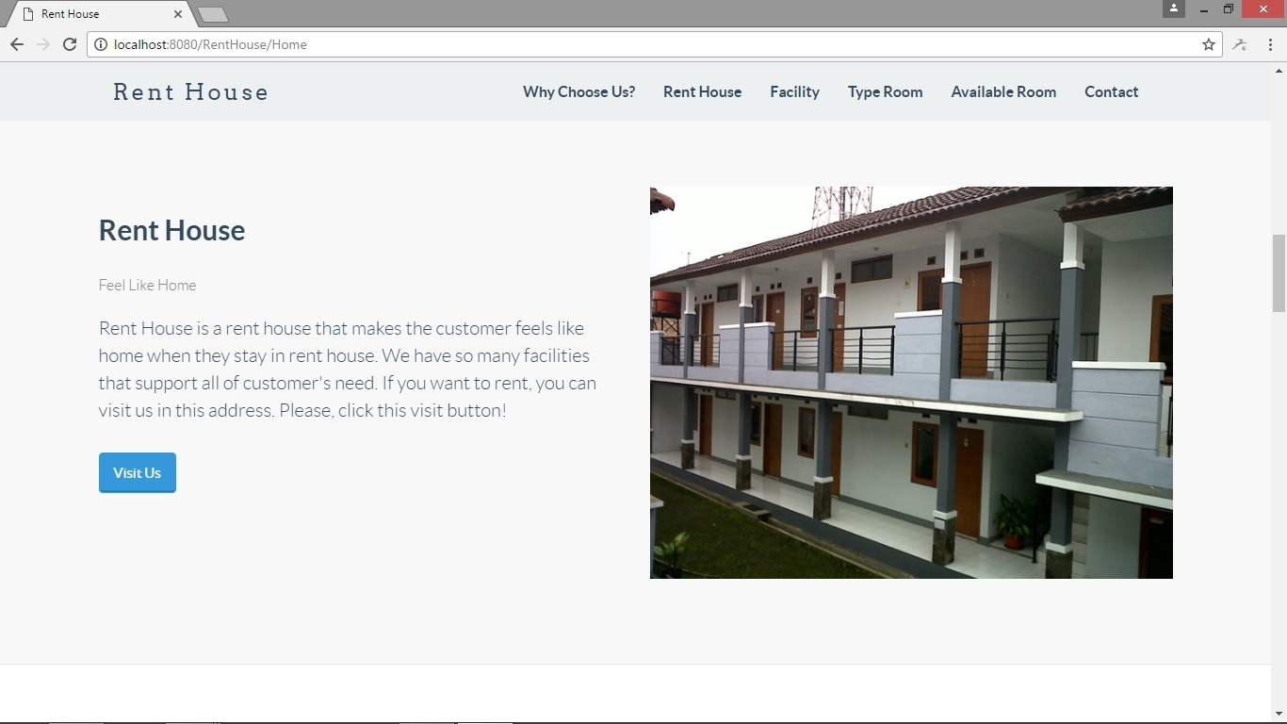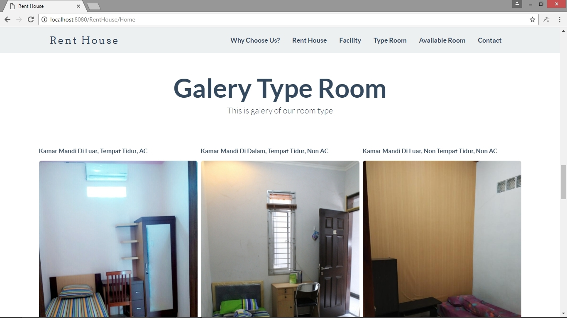

**INTERFACE OF RENT HOUSE FRONTEND**

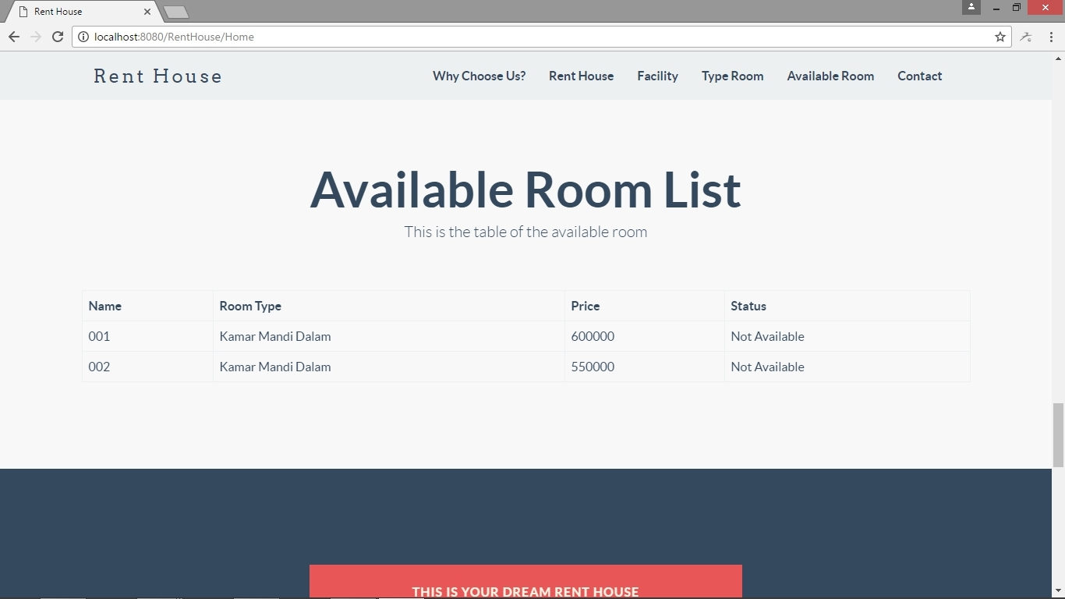

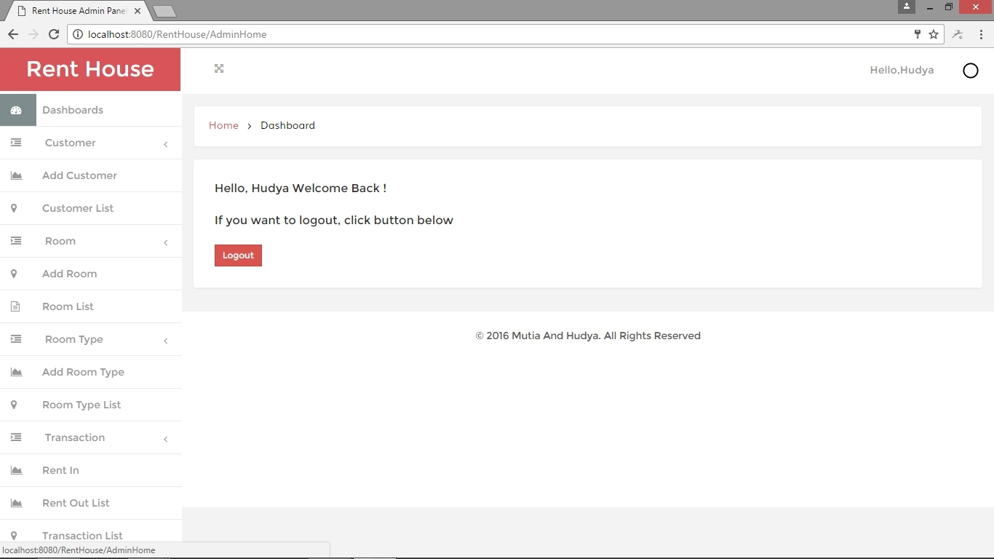

*Admin Home* 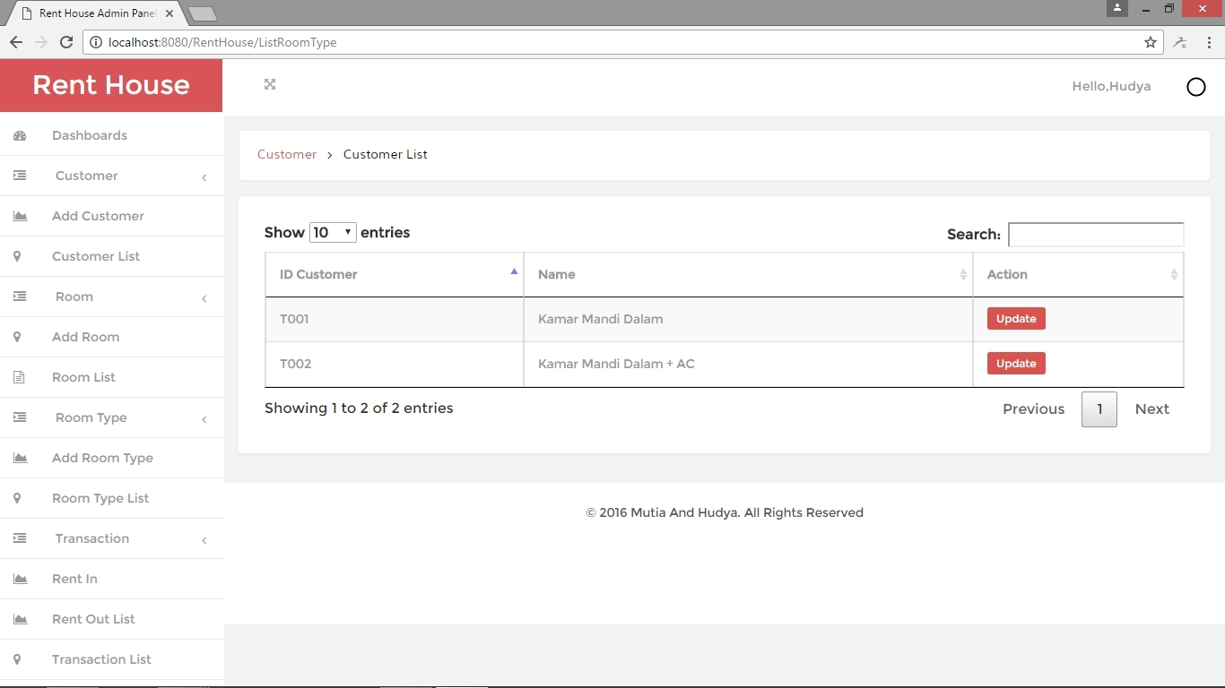

*List Room Type*

**INTERFACE OF RENTHOUSE BACKEND**

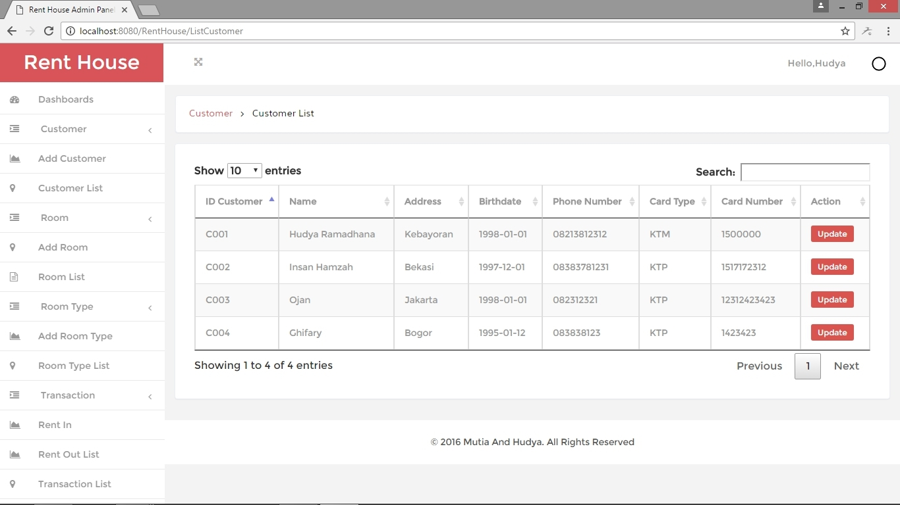

*List Customer*

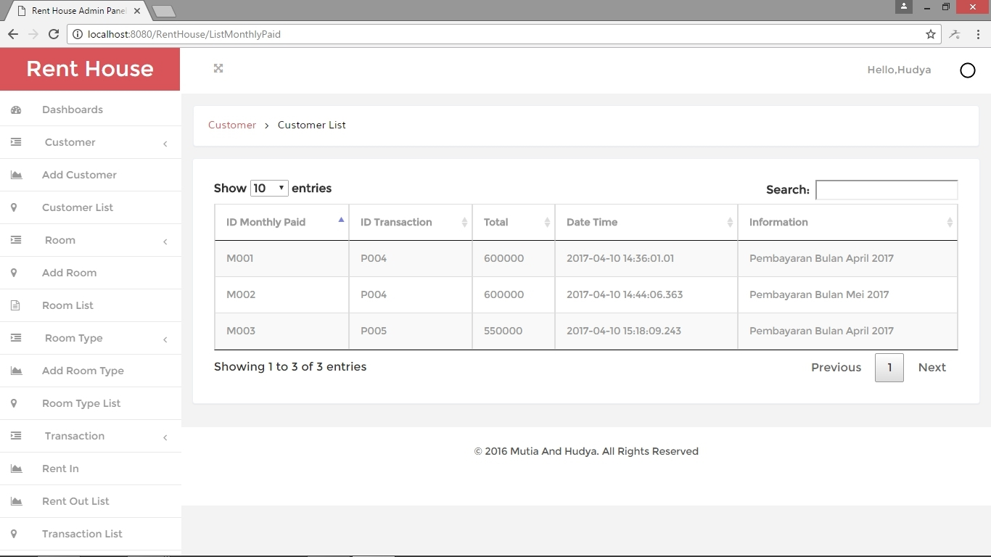

*List Monthly Paid*